Optimizing User, Group, and Role Management through Access Control and Workflows
Team Id:
Team size: 5
Team Leader : GAMPA JOSHNA
Team Member 1: NEELAPALA GAYATHRI
Team Member 2: PAVITHRA MIDUTHURI
Team Member 3: KUPPALA SURYA TEJA
Team Member 4: USHA GOKAVARAPU
Problem Context:
In a small project environment, a Project Manager (Alice) and a Team Member (Bob) are responsible for delivering tasks. However, the absence of well-defined roles, access restrictions, and structured workflows often creates confusion in responsibilities, accountability, and progress monitoring.

Objectives:
1. Role Definition: Clearly outline the duties of Alice as Project Manager and Bob as Team Member, ensuring both responsibility and access boundaries are transparent.
2. Access Control: Introduce mechanisms that limit Bob’s ability to create or edit projects beyond his assigned tasks, while still allowing him to view and update his responsibilities.
3. Workflow Organization: Establish a structured process that enables Alice to assign work, track task progress, and oversee completion in a timely and efficient manner.
Key Skills/Tools: Users, Groups, Roles, Tables, Access Control Lists (ACL), Workflow/Flow Designer.

TASK INITIATION
Milestone 1: Users
Activity 1: Create Users
1. Open service now
2. Click on All >> search for users
3. Select Users under system security
4. Click on new
5. Fill the following details to create a new user
6.Click on submit
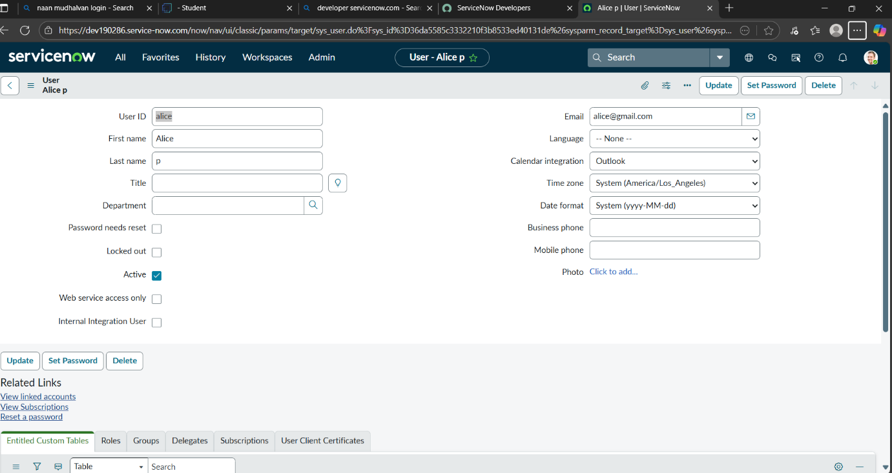
Create one more user:
7. Create another user with the following details
8. Click on submit
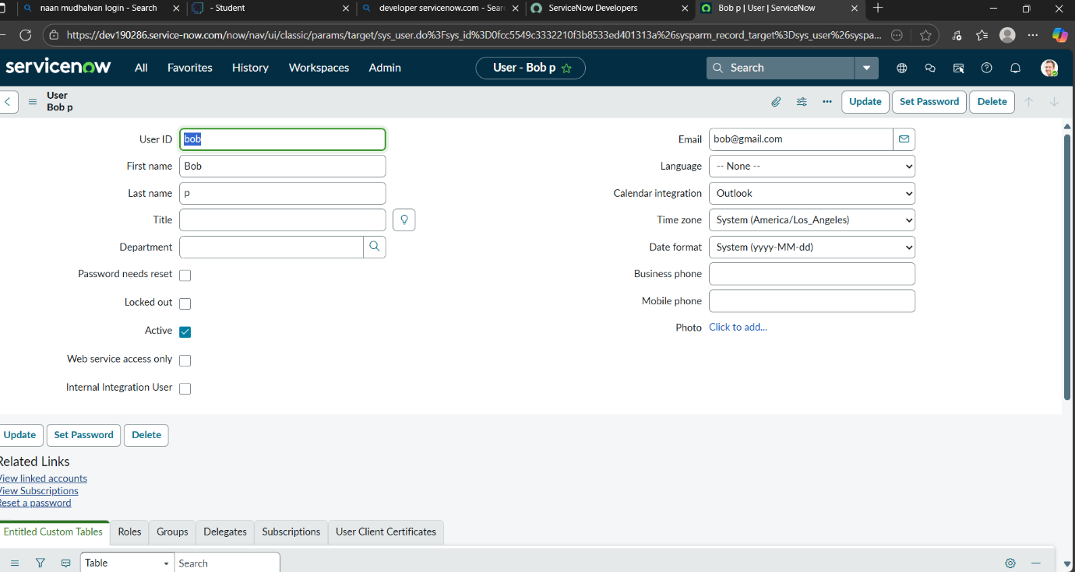

Milestone 2: Groups
Activity 1: Create Groups
1. Open service now.
2. Click on All >> search for groups
3. Select groups under system security
4. Click on new
5. Fill the following details to create a new group
6. Click on submit.
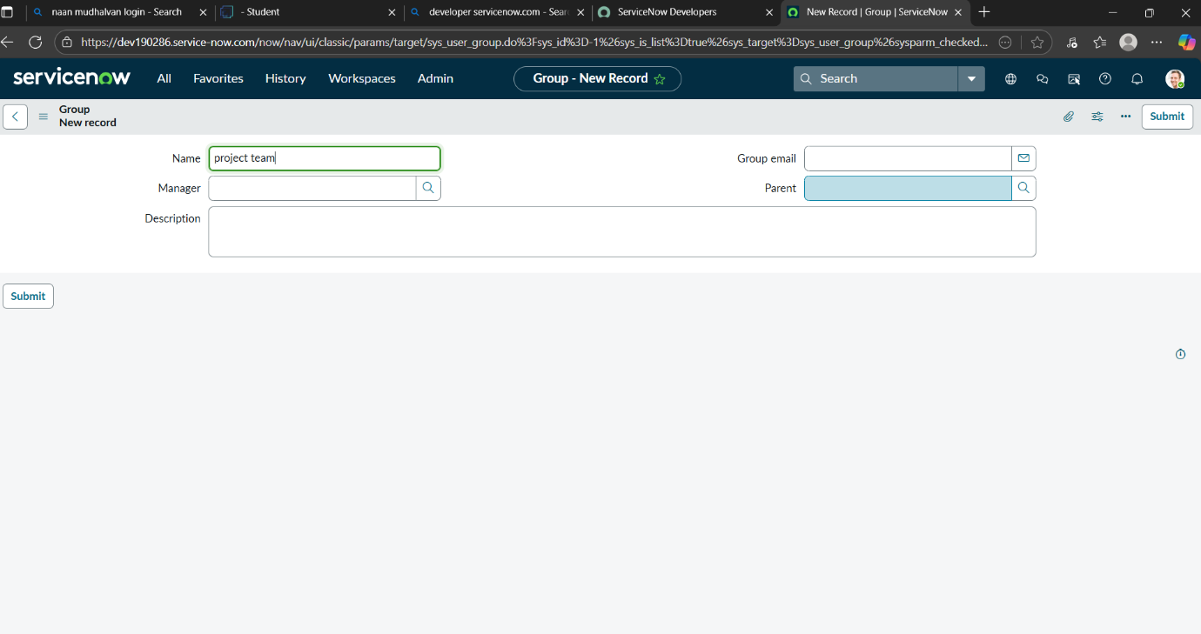
Milestone 3: Roles
Activity 1: Create roles
1. Open service now.
2. Click on All >> search for roles
3. Select roles under system security
4. Click on new
5. Fill the following details to create a new role
6. Click on submit.
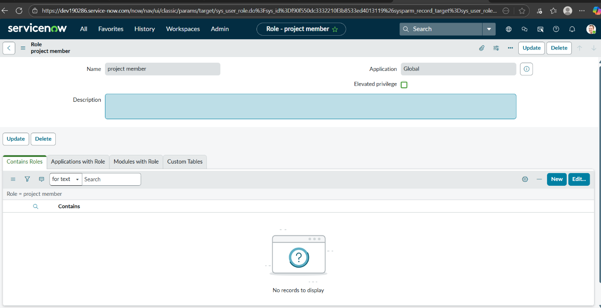
Create one more role:
7.Create another role with the following details
8.Click on submit
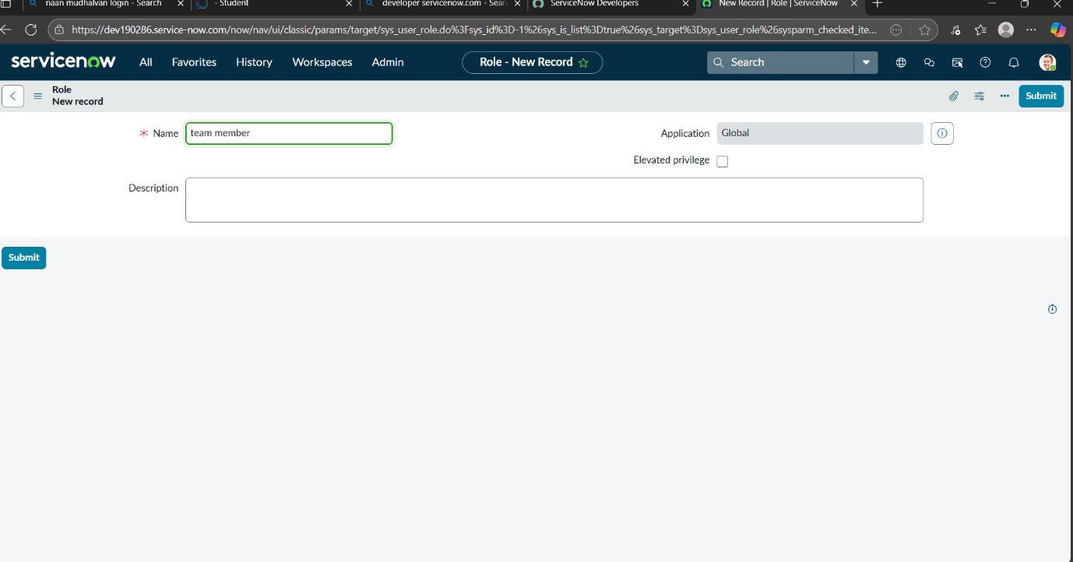

Milestone 4: Table
Activity 1: Create Table
1. Open service now.
2. Click on All >> search for tables
3. Select tables under system definition
4. Click on new
5. Fill the following details to create a new table
Label: project table
Check the boxes Create module & Create mobile module
6. Under new menu name: project table
7. Under table columns give the columns
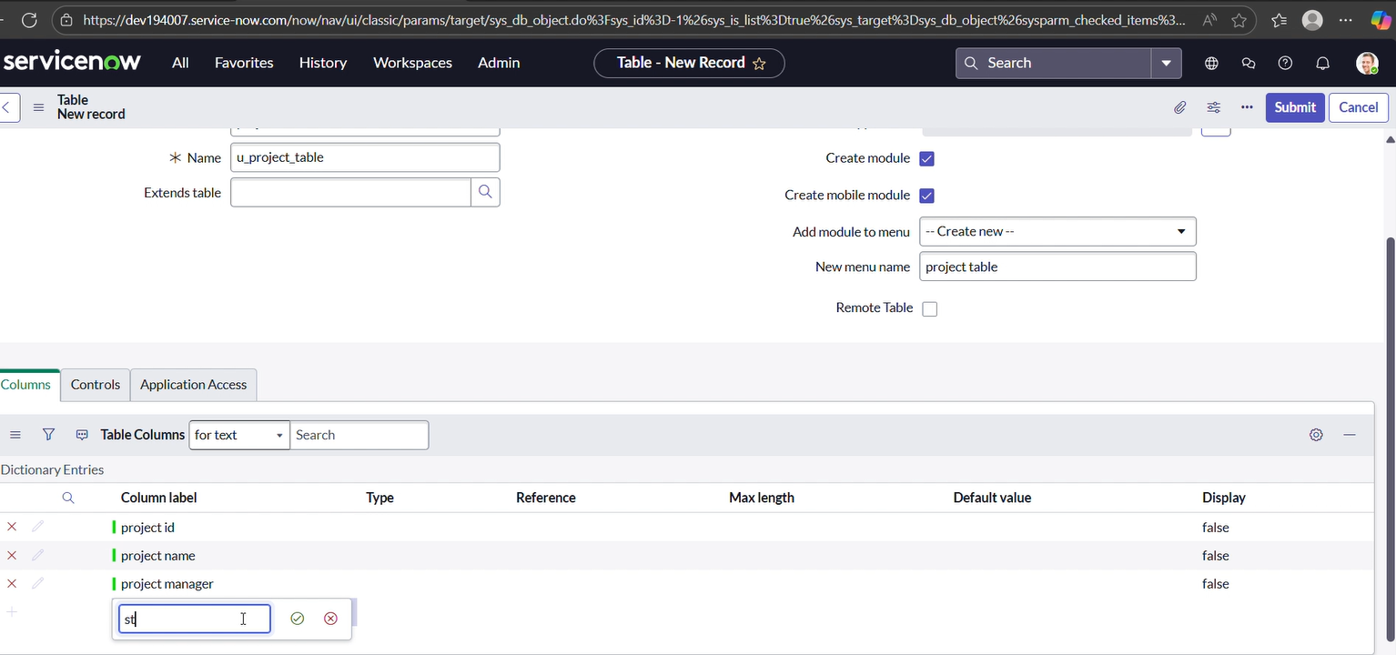

8. Click on submit
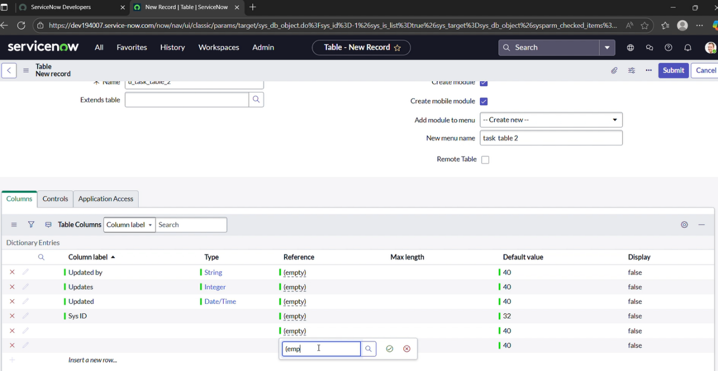
Create one more table:
9.Create another table as: task table 2 and fill with following details.
10. Click on submit.
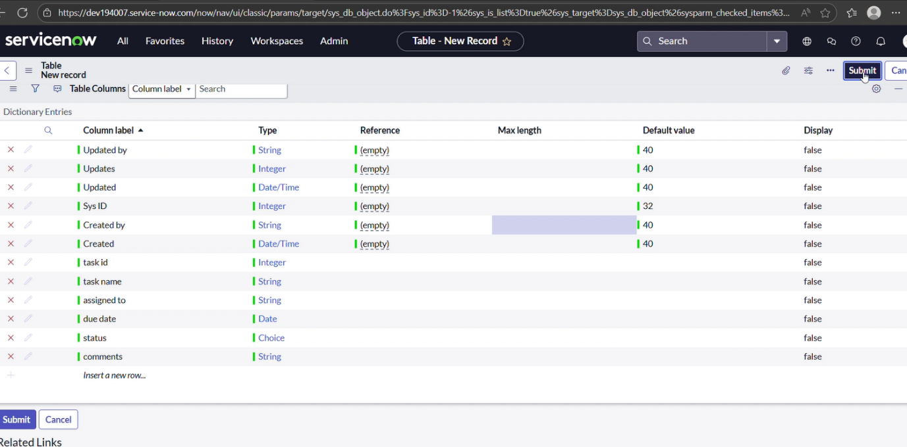
Milestone 5: Assign users to groups
Activity 1: Assign users to project team group
1.Open service now.
2.Click on All >> search for groups
3.Select tables under system definition
4.Select the project team group
5.Under group members
6.Click on edit
7.Select alice p and bob p and save
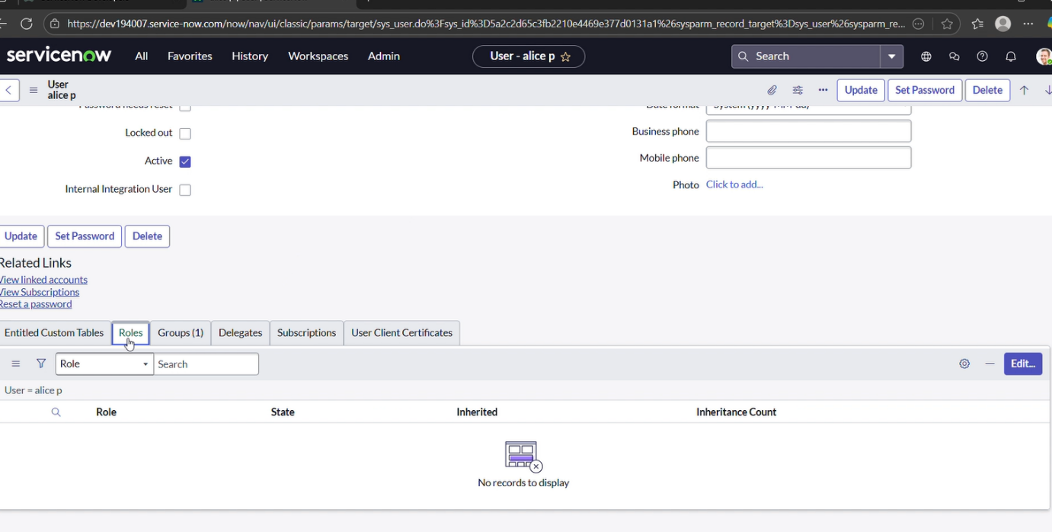

Milestone 6: Assign roles to users
Activity 1: Assign roles to alice user
1.Open servicenow.Click on All >> search for user
2.Select tables under system definition
3.Select the project manager user
4.Under project manager
5.Click on edit
6.Select project member and save
7.click on edit add u_project_table role and u_task_table role
8.click on save and update the form.
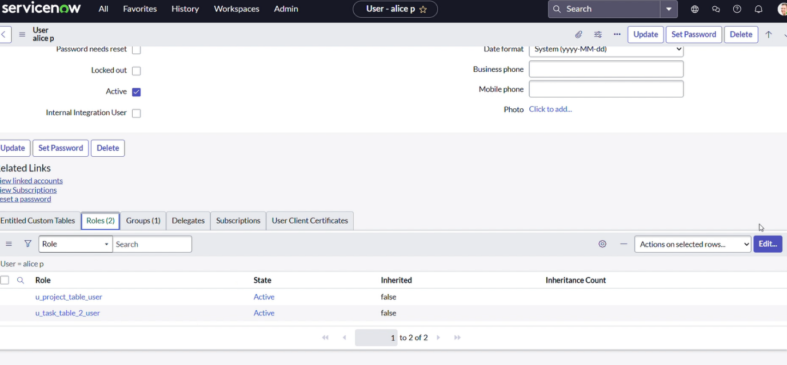

Activity 2: Assign roles to bob user
1. Open servicenow.Click on All >> search for user
2.Select tables under system definition
3.Select the bob p user
4.Under team member
5.Click on edit
6.Select team member and give table role and save
7. Click on profile icon Impersonate user to bob
8. We can see the task table2.
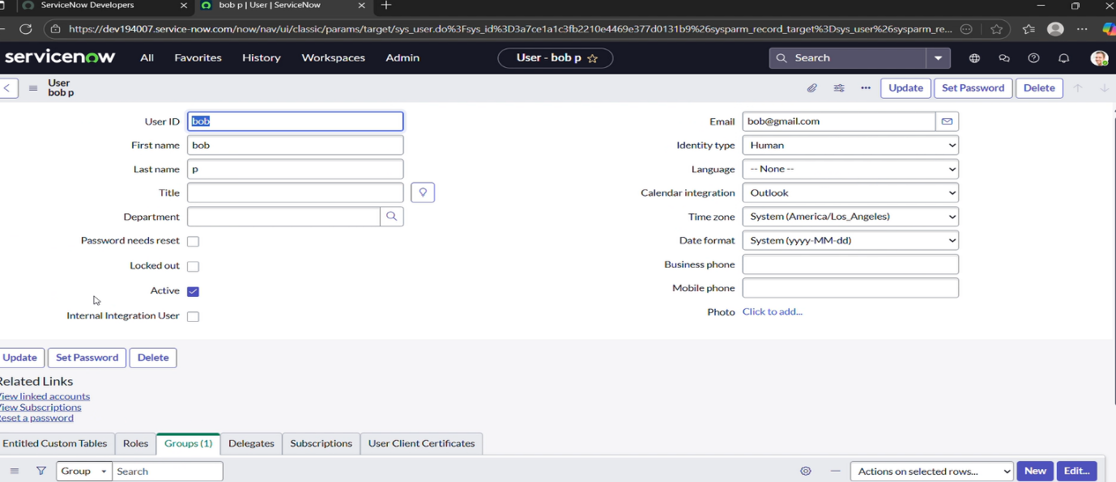
Milestone 7: Application access
Activity 1: Assign table access to application
1. while creating a table it automatically create application and module for that table
2. Go to application navigator search for search project table application
3. Click on edit module
4. Give project member roles to that application
5. Search for task table2 and click on edit application.
6. Give the project member and team member role for task table 2 application
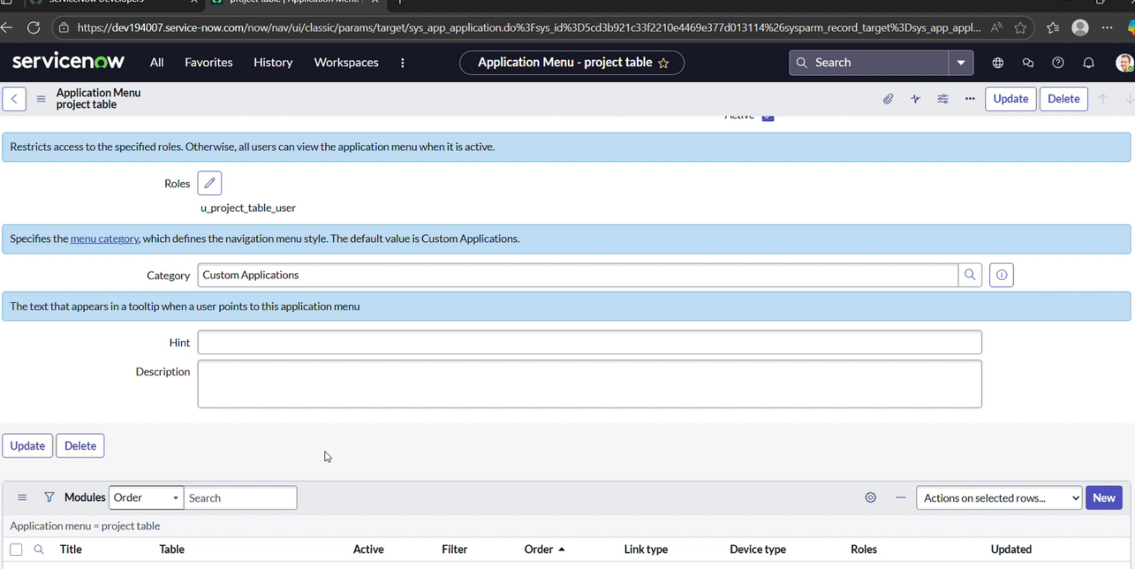
Milestone 8: Access control list
Activity 1: Create ACL
1. Open service now.
2. Click on All >> search for ACL
3. Select Access Control (ACL) under system security
4. Click on elevate role
5. Click on new
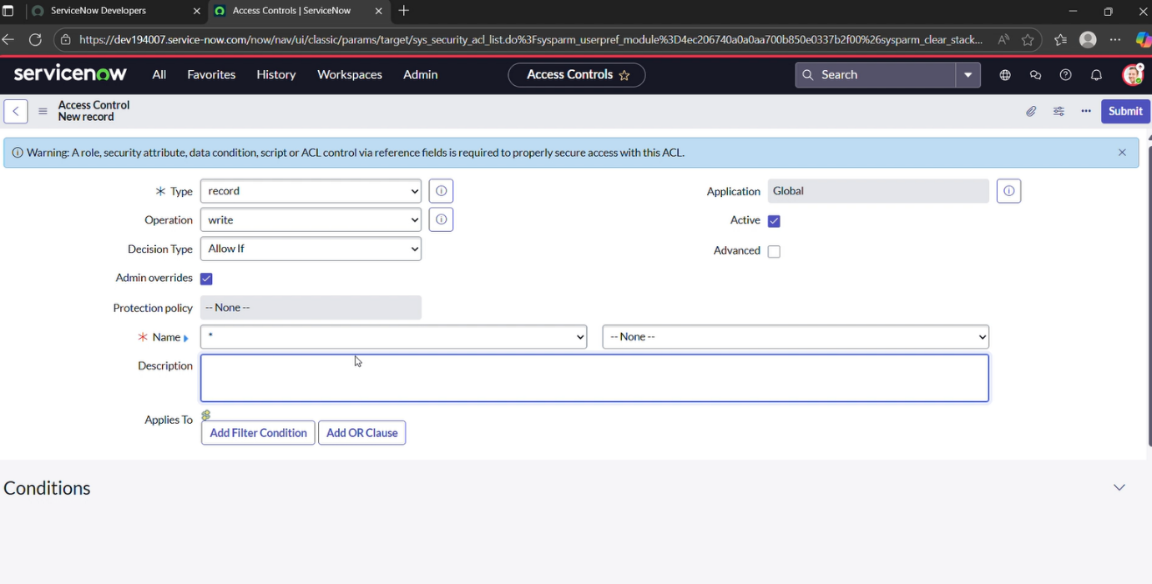
6. Fill the following details to create a new ACL
7. Scroll down under requires role
8. Double click on insert a new row
9. Give task table and team member role
10. Click on submit
11. Similarly create 4 acl for the following fields
12.Click on profile on top right side
13.Click on impersonate user
14.Select bob user
15.Go to all and select task table2 in the application menu bar
16. Comment and status fields have the edit access
Milestone 9: Flow
Activity 1: Create a Flow to Assign operations ticket to group
1. Open service now.
2. Click on All >> search for Flow Designer
3. Click on Flow Designer under Process Automation.
4. After opening Flow Designer Click on new and select Flow.
5. Under Flow properties Give Flow Name as “task table”.
6. Application should be Global.
7. Click build flow.
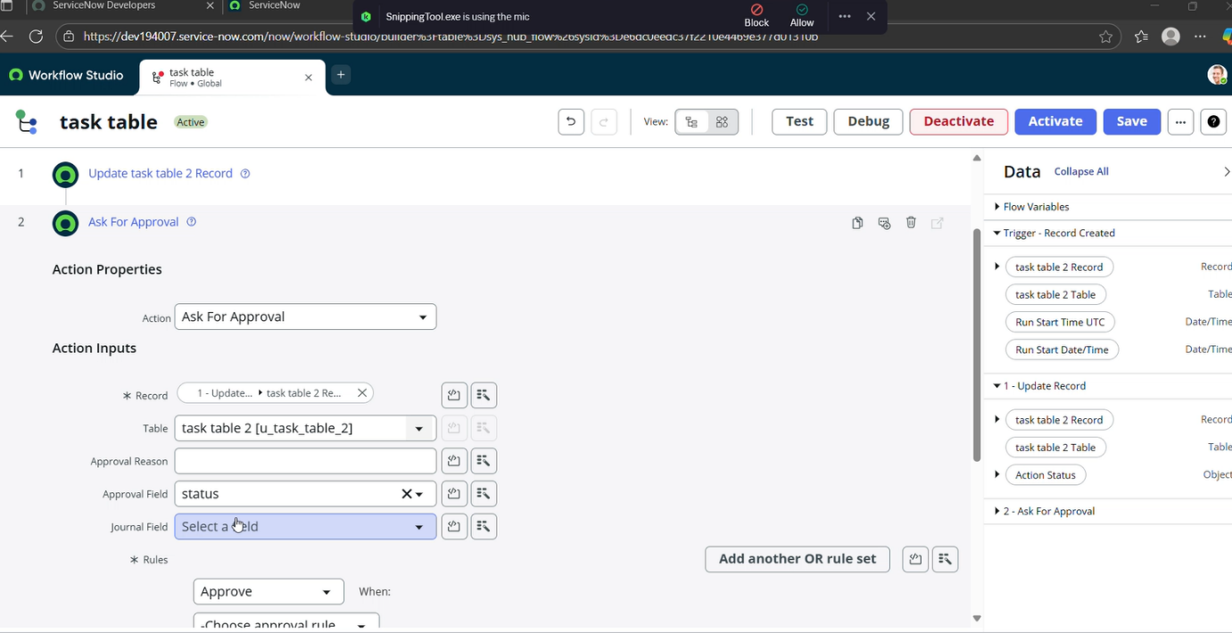
next step:
1. Click on Add a trigger
2. Select the trigger in that Search for “create record” and select that.
3. Give the table name as “task table”.
4. Give the Condition as Field: status Operator: is Value: in progress
Field: comments Operator: is Value: feedback
Field: assigned to Operator: is Value: bob
5. After that click on Done.
Next step:
1. Click on Add an action.
2. Select action in that, search for “update records”.
3. In Record field drag the fields from the data navigation from Right Side (Data pill)
4. Table will be auto assigned after that
5. Add fields as “status” and value as “completed”
6. Click on Done. 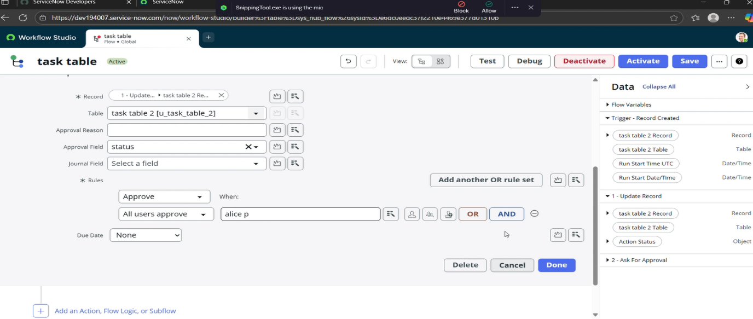

Next step:
1. Now under Actions.
2. Click on Add an action.
3. Select action in that, search for “ask for approval”.
4. In Record field drag the fields from the data navigation from Right side
5. Table will be auto assigned after that
6. Give the approve field as “status”
7. Give approver as alice p
8. Click on Done.
9.Go to application navigator search for task table.
10. It status field is updated to completed
11.Go to application navigator and search for my approval
12.Click on my approval under the service desk.
13. Alice p got approval request then right click on requested then select approved
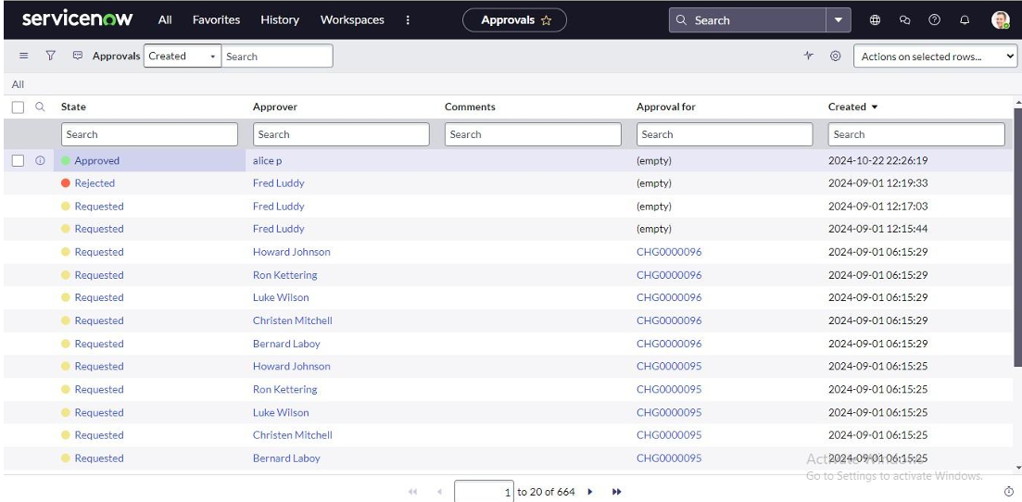

Conclusion:
This approach provides a streamlined system for managing projects by defining roles, applying access restrictions, and organizing workflows. It helps the team collaborate effectively, improves accountability, simplifies task tracking, and ensures successful project delivery.

